1. [IELTS Scoring in Details](https://ielts.org/organisations/ielts-for-organisations/ielts-scoring-in-detail)

**Listening:**

The IELTS Listening test contains 40 questions. Each correct answer is awarded 1 mark. Scores out of 40 are converted to the IELTS 9-band scale. Scores are reported in whole and half bands.

Here are the average number of marks scored at different levels of the IELTS scale in Listening section. The precise number of marks needed to achieve these band scores will vary slightly from test version to test version.

**Marks out of 40**

* **Band Score 5:** Listening 16
* **Band Score 6:** Listening 23
* **Band Score 7:** Listening 30
* **Band Score 8:** Listening 35

**Reading**

The IELTS Reading test contains 40 questions. Each correct answer is awarded 1 mark. Scores out of 40 are converted to the IELTS 9-band scale. Scores are reported in whole and half bands.

The IELTS Academic and General Training Reading tests are graded on the same scale. The Academic Reading test may contain texts which feature more difficult vocabulary or greater complexity of style. It is usual that a greater number of questions must be answered correctly on a General Training Reading test to secure a given band score.

Here are the average number of marks scored at different levels of the IELTS scale in Academic Reading, and General Training Reading sections. The precise number of marks needed to achieve these band scores will vary slightly from test version to test version.

**Marks out of 40**

**Academic**

* **Band Score 5:** Reading 15
* **Band Score 6:** Reading 23
* **Band Score 7:** Reading 30
* **Band Score 8:** Reading 35

**General Training**

* **Band Score 4:** Reading 15
* **Band Score 5:** Reading 23
* **Band Score 6:** Reading 30
* **Band Score 7:** Reading 35

2, 雅思考试安排

**注意：**除口语考试外的其它三科连续考完，顺序为听力，阅读和写作。中间没有休息！口语考试需单独预约。

强烈建议在参加考试前按照实际流程在规定时间内完成一次模拟考试。

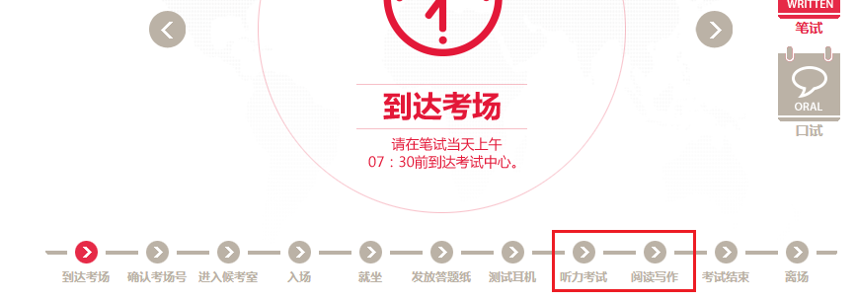

[考试安排](https://www.chinaielts.org/ielts_test_day/test_day_procedure.shtml)

